Villa, Joshua Alexander

Liwag, Jon Carlitos

MP 1-Matlab Screenshots

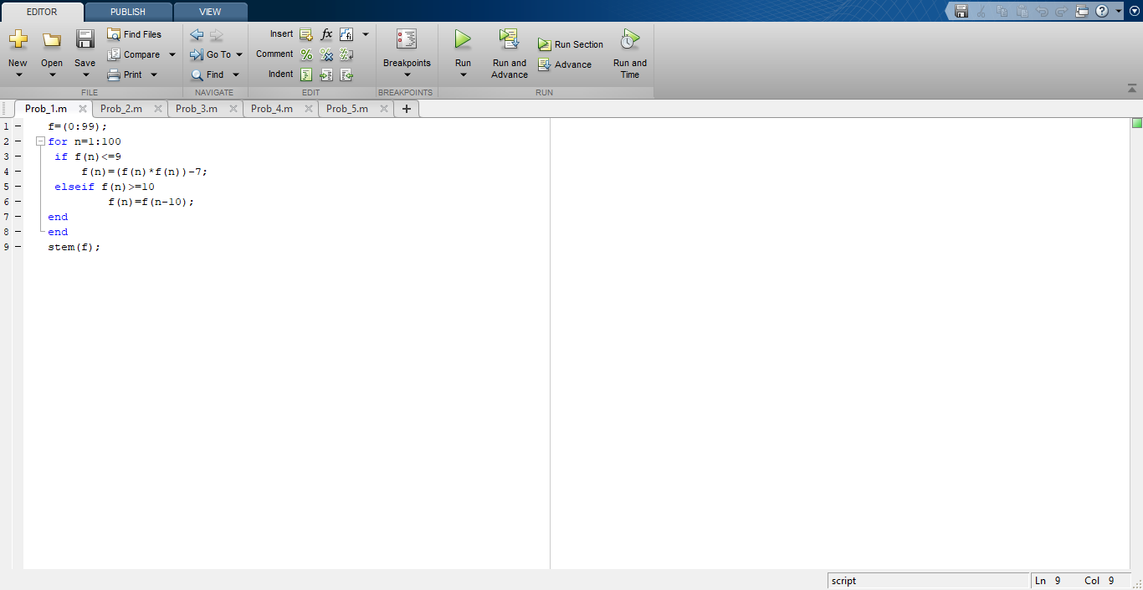

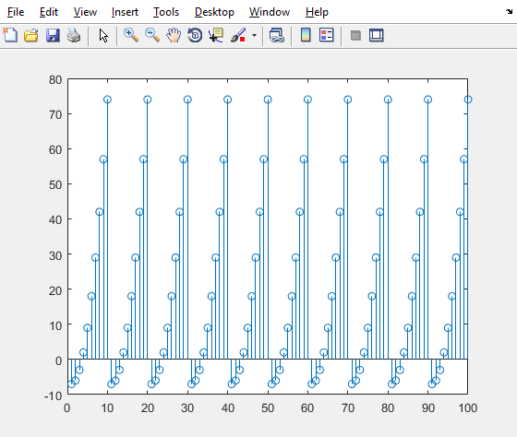

The graph starts below zero and ends above 70, it repeats the same pattern at the interval of 10.